REGISTRATION & REPORTING

Incorporated bodies are required to register with DMIRS
https://associations.commerce.wa.gov.au/associations/public/publicHomePage.jspx
https://associations.commerce.wa.gov.au/associations/public/enrol.jspx

We must also lodge information statements within 6 months of AGM:

Requirement of the Act | Complied | Guidance notes
Association contact details lodged with Consumer Protection are up to date (s175). | ☐ Yes  ☐ No | When a change occurs the address must updated within 28 days. The notice can be made using AssociationsOnline.  Help guide: Managing my association’s details
Associations Information Statement submitted (s156). | ☐ Yes  ☐ No | An information statement must be lodged every year within 6 months after the end of the association’s financial year.  Video: Lodge annual information statement

For more information, see Annex A Associations Self Checklist

TAX

With effect 1 July 24, Associations are also required to complete a self assessment:

https://tv.ato.gov.au/section/c-b6bh5x9
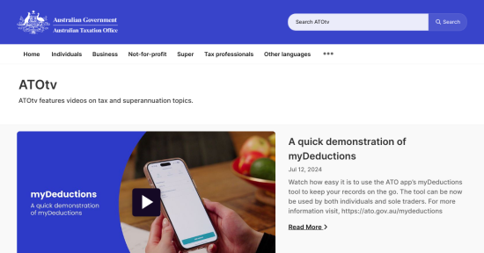 | Not-for-profit  Tax and super information for not-for-profit organisations.  tv.ato.gov.au

https://tv.ato.gov.au/media/c-b6bh5x9/bi9or7orfgpdsm
New reporting requirements for not-for-profits
From 1 July 2024, non-charitable NFPs with an active Australian business number (ABN) must lodge an annual NFP self-review return to self-assess as income tax e...
tv.ato.gov.au

